**IO Statistics**

**1: iostat**

**iostat** is the basic workhorse utility for monitoring I/O device activity on the system. It can generate reports with a lot of information, with precise content controlled by options. The general form of the command is:

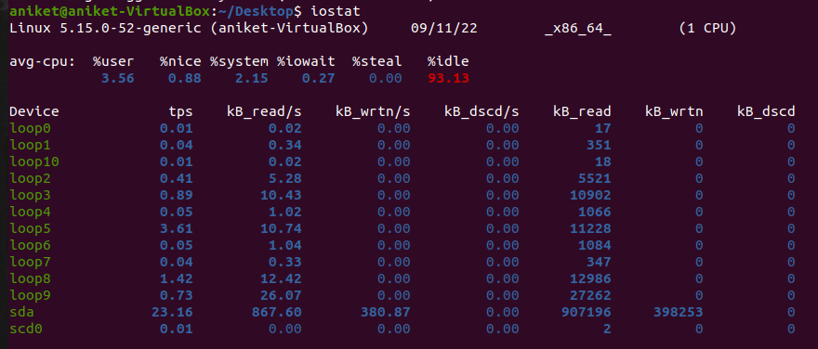

2: iostat -x

Shows more detailed statistics



3: iostat -c

Shows the CPU stats

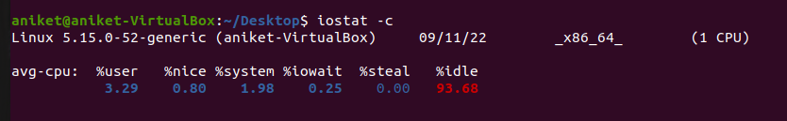

4: iostat -d

Shows the detailed device report

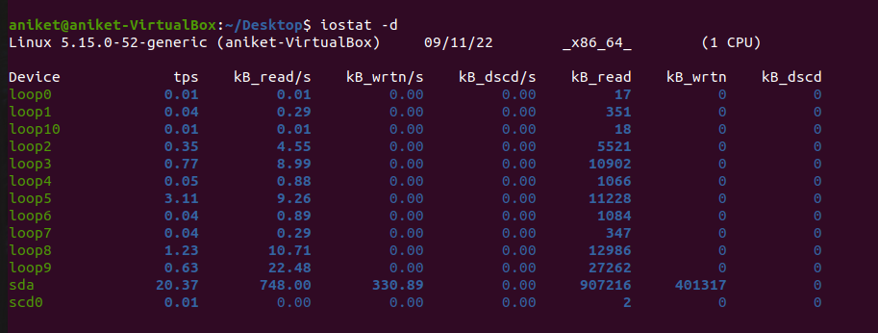

5: iostat -xd

Shows extended information regarding devices

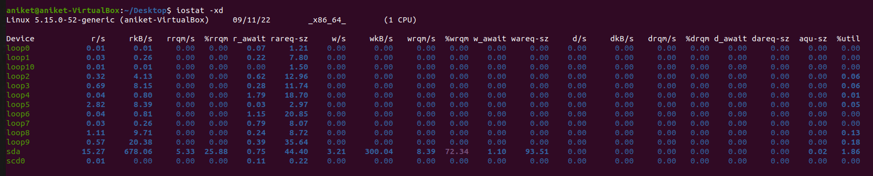

6: iostat -k

Shows the statistics in Kilo-Bytes or Mega-Bytes

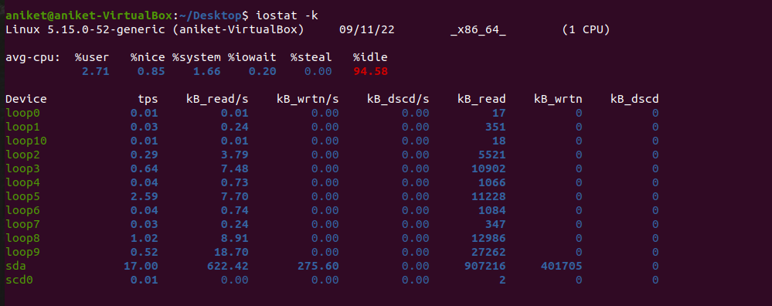

7: htop

**htop** command in Linux system is a command line utility that allows the user to interactively monitor the system’s vital resources or server’s processes in real-time.

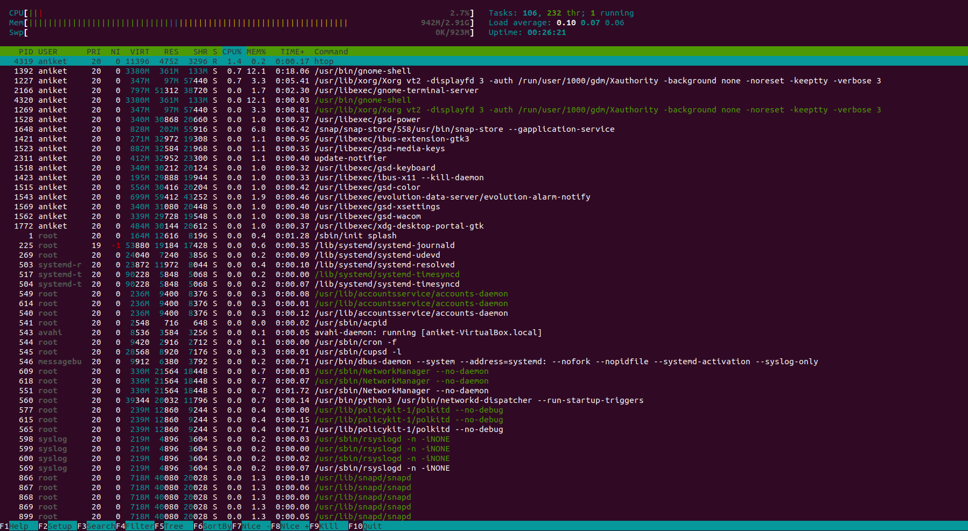

**Disk Partitioning**

1. To view the available Hard Disk in your system

**fdisk -l** or

**lsblk**

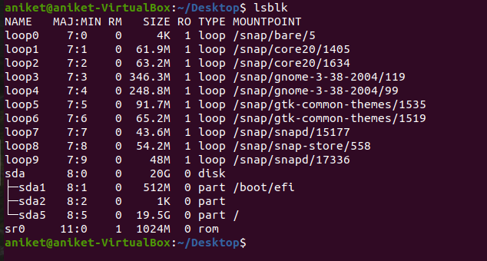

**2. Unmount the partition:**

**umount /dev/sda2**

**3: Run fdisk disk_name.**

**sudo fdisk /dev/sda2**

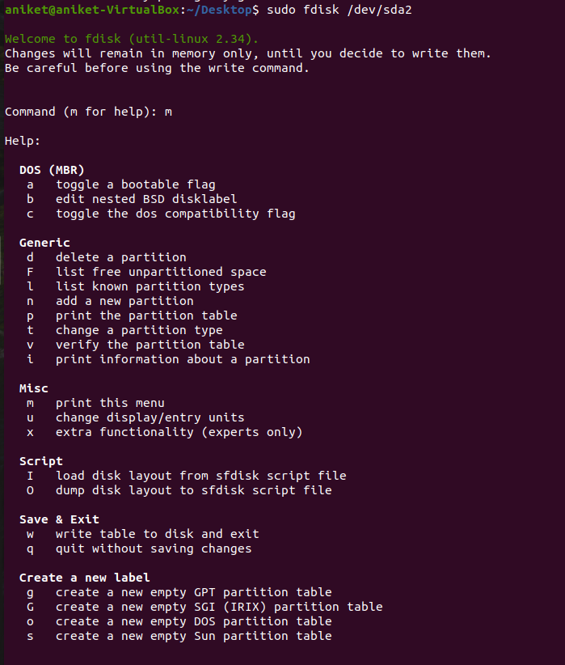

**4. Check the partition number you wish to delete with the p. The partitions are listed under the heading “Device”.**

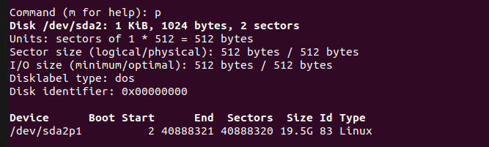

**5. Use option n to create a new partition. Follow the prompts and ensure you allow enough space for any future resizing that is needed. It is possible to specify a set, human-readable size instead of using sectors if this is preferred.**

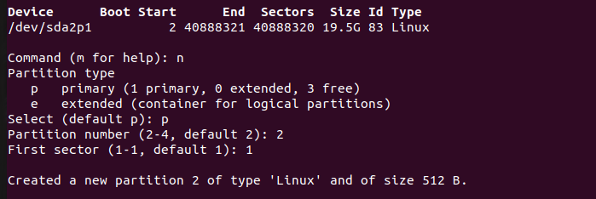

**6. Check the partition table to ensure that the partitions are created as required using the p option.**

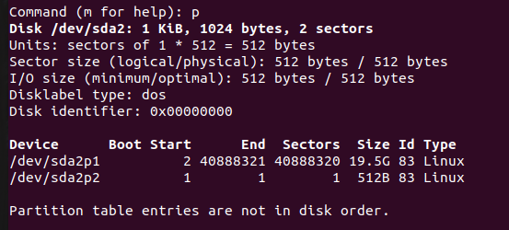

**7: Write the changes with the w option when you are sure they are correct.**

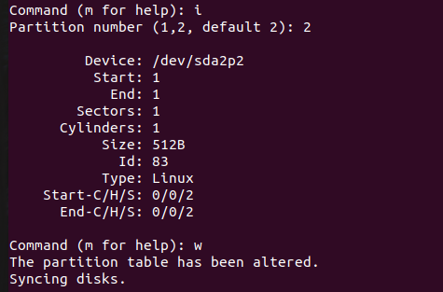

**8. Run mkfs to format the partition.**

**mkfs.ext4 –j /dev/sda2p2**

**9. Mounting the file system**

**mkdir /mount_dir**

**mount /dev/sda2/mount_dir**

**df –h // to view disk details**

